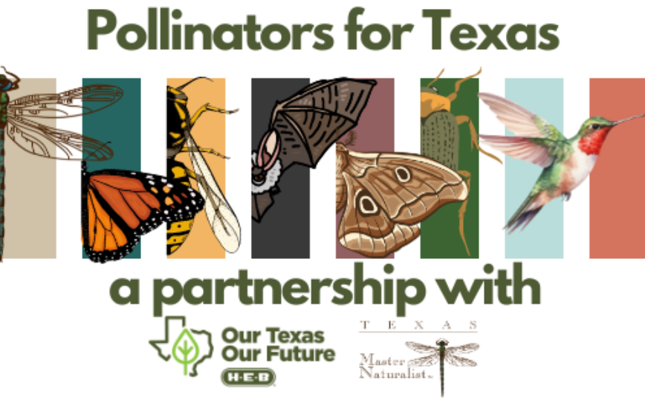

**Pollinators for Texas – Project**

Pollination is a critical ecosystem service that helps to maintain the ecological integrity of native plant communities. Native pollinators—bees, butterflies, moths, bats and birds—play a critical role in sustaining ecosystems and provide essential services to American agriculture ([estimated at as much as $9 billion annually](https://www.usda.gov/pollinators)). Interest in conservation of native pollinators has grown rapidly over the last few years as several species have experienced dramatic population declines.

**Project Details:** Texas Master Naturalist Chapters are invited to apply for a Pollinators for Texas project funding, generously sponsored by H-E-B, with the goal of making large scale impacts for pollinator habitats. This could include developing and expanding on the ground conservation and habitat projects and significant outreach programs focused on native pollinators and pollinator habitat conservation. Projects must follow TMN service guidelines, be publicly accessible and include a care and maintenance plan for post-project longevity. Projects may include installation of large-scale pollinator habitat, interpretative signage or enhancement of current Texas Master Naturalist pollinator projects, public educational programming focused on pollinators, or innovative conservation projects focused on native pollinators and their habitats. The goal of this program is to utilize funding from H-E-B to generate measurable positive impact on native pollinators and their habitats across the state of Texas, while improving the communities in which H-E-B employees and customers live, work, and recreate.

**Project Award Amount:** Variable funding up to $3,000 for projects

**Funder:** The Texas Master Naturalist Program in partnership with H-E-B

**Application Submission Period:** October 1 – November 30, 2024

**Notification of Award:** January 2025

**Project Completion Deadline:** Projects should have measurable impacts (i.e. plants, acres, hours, outreach) by **November 1st, 2025** with all funding spent by this date. Please note in your application if your project will not be complete by this time.

**Project Report Deadline:** A mid-year and final full report form will be sent to all Chapter award recipients to complete. The mid-year project report will be due in **July**. All project final reports are due to the TMN State Office no later than **December 1st 2025**. A statewide impact report will be compiled by **December 31st 2025**.

**Application Materials:** Applicants must complete the online application form in its entirety for their application to be considered submitted and eligible for consideration. If you would like to work on your application prior to submission (the form will not let you save progress) you may download a Word version HERE: Application - Word Version. Please note, the Word version is for your personal use only - applications MUST be submitted via this form!

**Eligibility:** All Texas Master Naturalist Chapters are eligible to apply. Projects submitted must first be coordinated with and approved by your Chapter’s board locally. Chapters located within an H-E-B region will be given priority in funding. This does not exclude those chapters in non-HEB regions (West Texas and the Panhandle); however, projects must be clearly tied to pollinators or those that will migrate through this region to other parts of the state.

**VMS:** All TMN volunteer service hours worked in connection with this Pollinators for Texas project must be logged as required in VMS within 45 days. Hours contributed to the project in September and October MUST be logged by October 31st, 2025.

**Project Considerations:**

* Application for project funding must be received via the online application form within the designated application period to be considered for the relevant project cycle.
* Projects on private property are not eligible.
* Priority will be given to projects proposing large scale or regional pollinator focused projects not normally accessible to chapters without these funds. Neighboring Texas Master Naturalist Chapters may consider working jointly on these landscape level projects in a region.
* Priority will be given to projects engaging with and involving local communities.
* This Pollinators for Texas project does not support funding for advertising, individuals, transportation, political events, or fundraisers of any kind.
* All applicants must provide a long-term maintenance and care plan for their project. Funding from the project may be spent on irrigation/care as needed. Project budgets will be reviewed with impacts prioritized.
* All selected projects must incorporate either physical signage or a social media marketing plan. Guidelines for marketing will be shared with selected projects.
* All selected projects must fill out a post-project report detailing the final impact of the project. Projects are to be completed by November 1st, 2025.

**Applicant Information**

1. Lead Chapter Name
2. Chapter Address
3. Contact Name
4. Contact Email
5. Contact Phone
6. Chapter Website
7. Chapter Social Media

Please share links to your Facebook, Instagram, Twitter, or other relevant channels

Add Co-Chapters below.

**Project Information**

1. Project Name

If the project doesn't have a formal name that is okay, please provide a descriptive title of efforts - i.e. X park's restoration efforts, etc.

1. Project Website (if applicable)
2. Project Location

County, City, or full address.

1. Project History & Background

How did the project start? What was the catalyst? If this is a new initiative, what led to its formation?

1. Project Goals & Objectives

What is the purpose of the project? What needs are being met? What are the goals? How are you achieving them?

1. Project Need

Please explain the need for this project, using data where possible and addressing species where possible to demonstrate the necessity and effectiveness of your proposed solution.

1. Project Partners

Please list partners you will be working with to implement this project. Include a description of their roles and resources they are committed to bringing to your project’s success. Though project funding match is not required, please list and describe any partial or full funding match your partners may be bringing to your project.

1. Planting/Event Date

Provide a date for your planting/events if possible.

**Project Impacts**

1. Project Impact – How does this project increase habitat or conservation acres of native pollinator species?

Please provide data where possible.

1. Project Impact – How does this project engage the community? Provide details on how the community will become involved and what education and outreach services this project would provide for the community.

Please provide data where possible.

1. Project Impact – How does this project increase chapters’ partnership with other community groups/organizations? How could this project potentially impact recruitment of new Texas Master Naturalist volunteers?

Please provide data where possible.

1. Estimated # of volunteer hours to complete the project.

Include hours from all TMN volunteers

1. Outline the total number of people participating in the initiative (i.e. physically involved in administration, implementation or operation of project):

Please share details of those that will be included, partners, volunteers, and any other participants impacted with the project.

1. Outline the total number of people benefiting, such as populations served, and/or people involved that are positively impacted by the project/program. (i.e. potential reach of project)

Please answer numerically (ex: 23 students, 1,000-1,500 residents, etc.)

**Project Details - Natural Resources**

1. Project Size

Provide impact area in acres, if possible. Close approximations are acceptable - please share details. 1 acre = 43,560sq ft

1. If a planting project, how many plants are anticipated to be planted?
2. What species are planned to be planted? (Please attach a list if needed)
3. What is the post-project plan for care, evaluation or follow-up?

If providing education, how will you evaluate your return on investment? If planting plants how will you ensure their success? Include: All watering and fertilizing plans, parties responsible for tracking health/status of the plants, etc. You may also submit it as a separate document at the end of this application. There are no strict requirements, as we understand different locations and different projects will have different needs, this is simply to confirm that post-project care is thought through and accounted for!

1. Describe how you will measure or evaluate how this project has made a positive impact for pollinators and their habitats and at what intervals.
2. What other natural resources will benefit from the project?

Examples include types of plants, wildlife, waterways, habitat areas, etc.

1. Estimated Investment in project to date

Estimated funds you have spent to date if this is a continuation of a current project. Please answer numerically without the $ symbol

1. If awarded, how will the funding be spent?

Please provide a detailed breakdown of anticipated spending, such as plants purchased, mulch, equipment rentals, etc. Funding may be spent on items other than plants to ensure project completion. You may also share a budget document at the end of the application if you already have one prepared.

**Recognition & Documentation**

1. How will this project award be recognized?

Please share plans for social media, press release, or other marketing methods. The Texas Master Naturalist state office will also share a press and social media tool kit with all chapter awardees to assist with announcements.

1. If available, submit any photos of the project area ("Before” photos with "after" photos to be collected after project completion) “During” photos are also encouraged to be collected.
2. Is there anything else you would like to share?
3. Please upload the following documents here:

* Project Budget (if not included above)
* Post-Project Maintenance Plan (if not included above)
* Project plan (i.e. schematic, layout)
* Any other supporting documentation
* AgriLife Vendor Application (W-9)